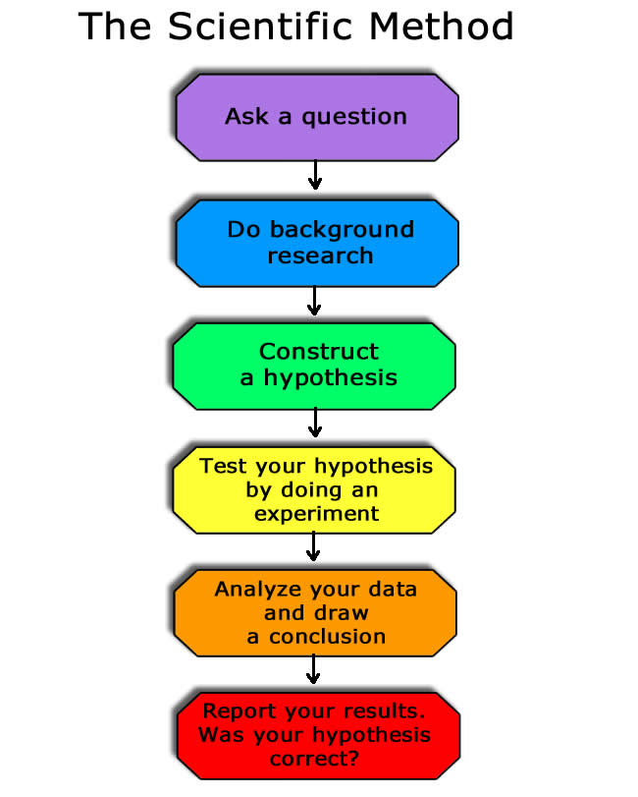
Put on your Lab coat and practice using the Scientific Method in your experiment.
Anyone can do it… Just follow these steps:
- The Question
Your science fair project starts with a question. This might be based on an observation you have made or a particular topic that interests you. Your question needs to be about something you can measure and will typically start with words such as what, when, where, how or why.
- Background Research
Use resources such as books and the Internet to perform background research on your question. Gathering information now will help prepare you for the next step in the Scientific Method.
- Hypothesis
Using your background research and current knowledge, make an educated guess that answers your question. Your hypothesis should be a simple statement that expresses what you think will happen.
- Experiment
Create a step by step procedure and conduct an experiment that tests your hypothesis. Repeat the experiment a number of times to ensure your original results weren’t an accident.
- Data and Observations
Collect data and record the progress of your experiment. Document your results with detailed measurements, descriptions and observations in the form of notes, journal entries, photos, charts and graphs. Describe the observations you made during your experiment.
- Conclusion and Report
Use your data and observations to answer your original question, do the results of your experiment support or oppose your hypothesis? Present your findings on a poster or display board.

